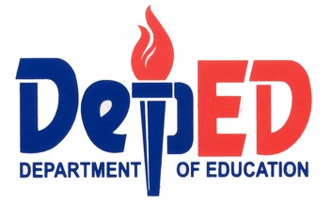
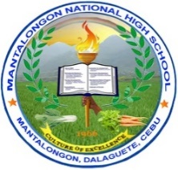

Region VII, Central Visayas
DEPARTMENT OF EDUCATION
DIVISION OF CEBU PROVINCE
District of Dalaguete

MANTALONGON NATIONAL HIGH SCHOOL
Mantalongon, Dalaguete, Cebu

School Memorandum October 3, 2018
No. 4, s. 2018

TRAINING FOR DIVISION SCHOOLS PRESSCON AND DIVISION SCIENCE FAIR PARTICIPANTS

TO: All Advisers and Subject Teachers

- This is to inform all Advisers and Subject Teachers to excuse all Presscon and Division Science Fair participants starting October 8-12, 2018 for their training in preparation for the Division Schools Press Conference on October 16-18, 2018 and Division Science Fair on October 15, 2018.
- All Subject teachers are directed to give enough time for the participants to comply all missed quizzes and activities.
- Participants will take the 2nd Periodical Test after the Semestral Break.
- Non-compliance of the said memorandum is subject to administrative liability.
- Wide dissemination and strict compliance of the school memorandum is hereby directed.

ROBERT C. CENIZA
Principal I

DIVISION SCHOOLS PRESS CONFERENCE PARTICIPANTS

NAME OF STUDENTS | GRADE LEVEL
- Jhan Aldrin Carilimdiliman | Grade 8
- Jane Crislyn Rubin | Grade 9
- Yoradel Ambrad | Grade 9
- Kisha Franz Yu | Grade 9
- Nerio Ditchon | Grade 9
- Dune Ignisha Orozco | Grade 9
- Janna Lee Denulan | Grade 10
- Mitchfel Gail Amamence | Grade 10
- Everette Glad Geslaga | Grade 10
- Adrienne Sabellano | Grade 10
- Joan Alliah Carilimdiliman | Grade 10
- Jovelen Dinglasa | Grade 11
- Hannah Carmela Mercado | Grade 12

DIVISION LEVEL SCIENCE FAIR PARTICIPANTS

NAME OF STUDENTS | GRADE LEVEL
- Isabella Mercado | Grade 7
- Yoradel Ambrad | Grade 9
- Mitchfel Gail Amamence | Grade 9
- Joan Alliah Carilimdiliman | Grade 9
- Jairah Mae Flores | Grade 9
- Michael Dave Flores | Grade 9

